1. Write a program to calculate student grade based on below rules:

A. 90 to 100 -> Grade A

B. 80 to 90 -> Grade B

C. 70 to 80 -> Grade C

D. Failure.

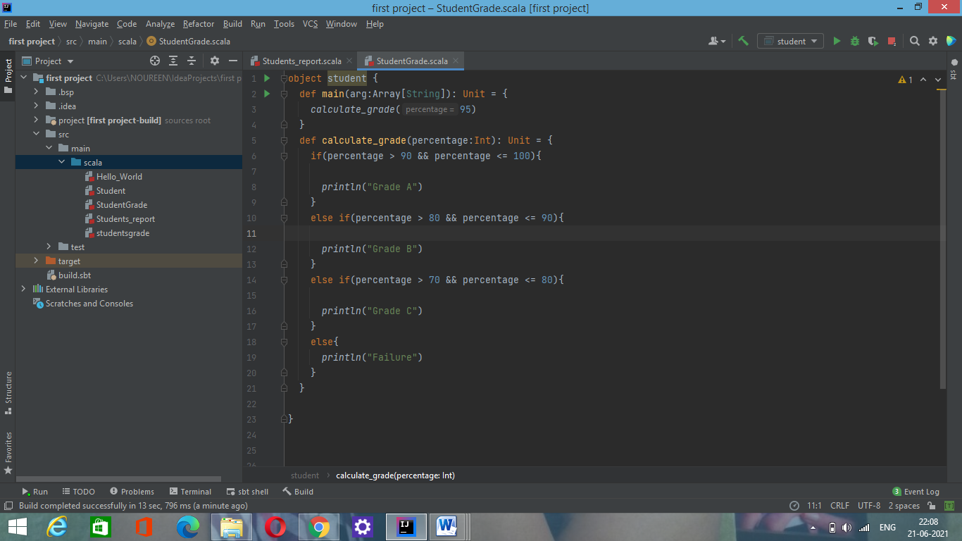

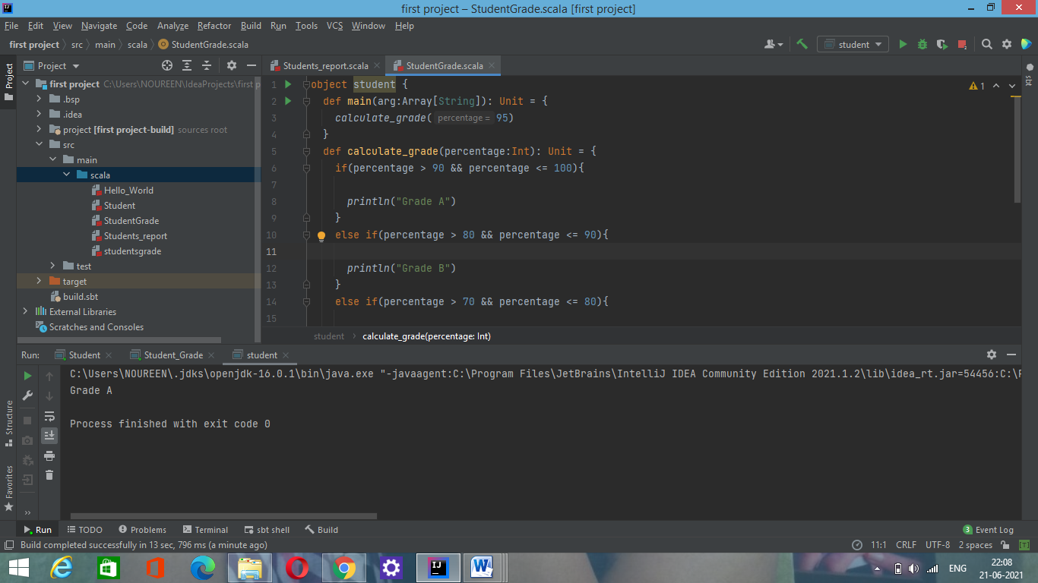

2. Write a Program to calculate maximum % scored student report from below data.

{id:101,name:raj,cmarks:45,pmarks:55,mmarks:67}

{id:102,name:rajesh,cmarks:65,pmarks:85,mmarks:77}

{id:103,name:suraj,cmarks:43,pmarks:55,mmarks:60}

{id:104,name:tom,cmarks:71,pmarks:65,mmarks:70}

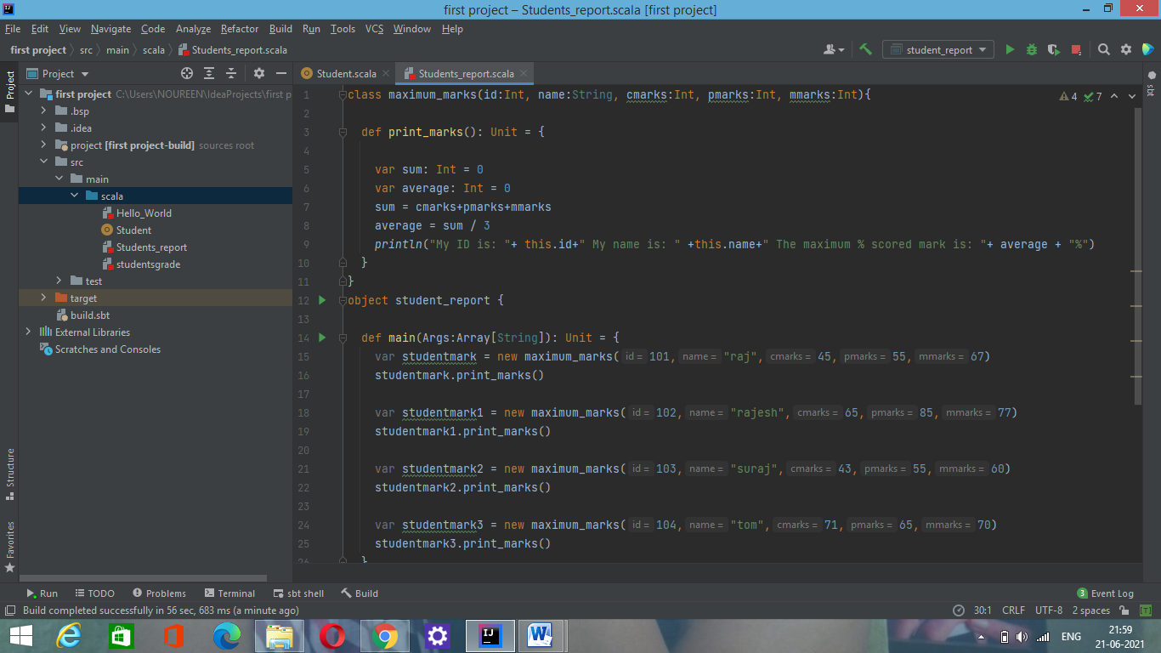

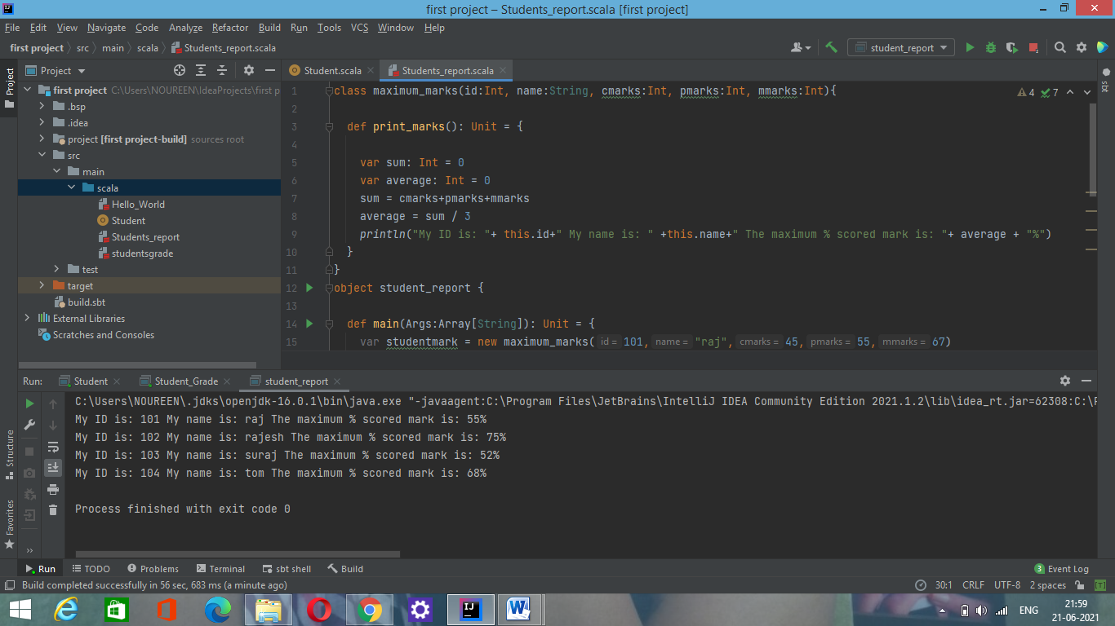

3. Write a program to perform sorting of below data based on id and name(create class, object and a method for sorting in util class)

{id:101,name:raj}

{id:121,name:rajesh}

{id:130,name:suraj}

{id:114,name:tom}

